**Tutorial 8 JavaScript(IV)**

1. (a) Draw the DOM tree of the following document. (Do not need to write the full content of the text node, refer to lecture note for reference)

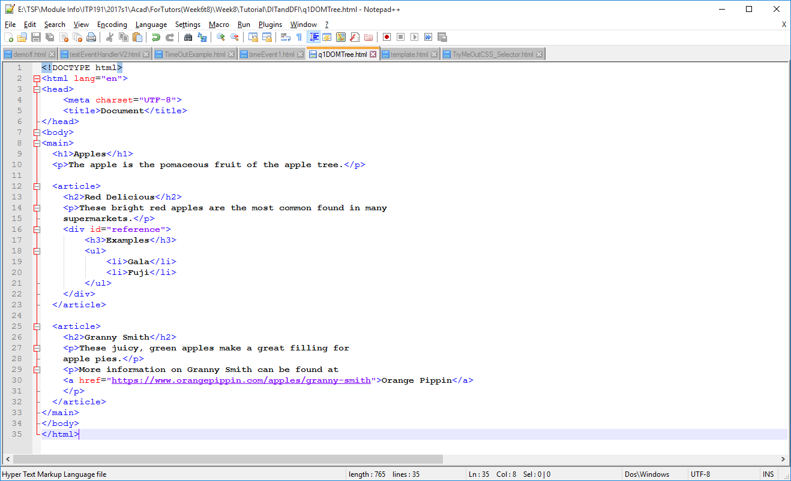

(b) How many **child nodes** does the node **main** have?

(c) How many **sibling nodes** does the node **h3** have?

(d) Which node is the **parent node** of the **a link** node which hyperlink to orange pippin?

(e) Write the statement which use document.getElementById() to get the **div** of id equal to **reference**.

(f) Write the statement which use document.querySelector() to get the **unordered list** under the div of id equal to reference.

(g) Write the statement which use document.querySelectorAll() to get **all the articles** under the node **main**.

(h) Write the statements to change the designated url of the a link to <https://en.wikipedia.org/wiki/Granny_Smith> and change **Orange Pippin** to **Wikipedia**.

* 1. Write the statements to add the following html content to the **main** node.

<footer>

<p>&copy;RGApple of Singapore</p>

</footer>

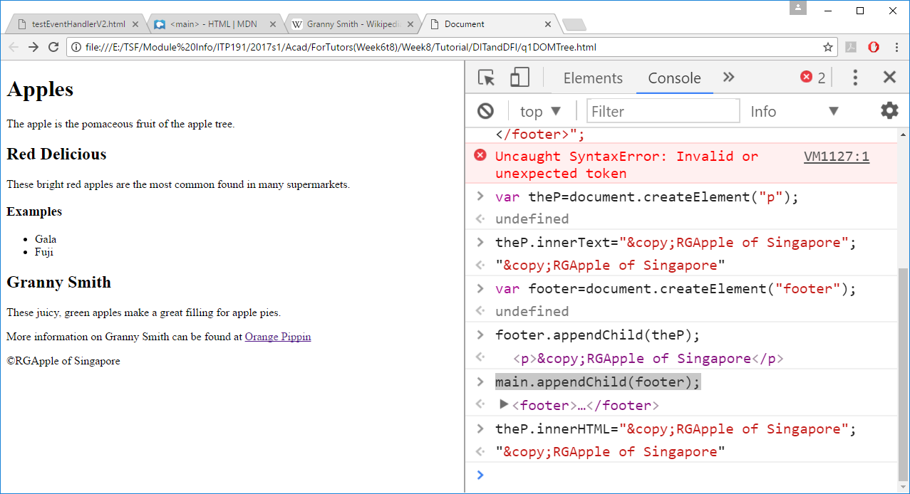

1. (a) Complete the following code such that after the web page loaded for 2 secs, the colour of the ball will be change from blue to red. Clear the timer after that.

<!DOCTYPE html>

<html lang="en">

<head>

<meta charset="UTF-8">

<title>Document</title>

<style>

#ball {

width:30px;

height:30px;

border-radius:50%;

}

</style>

<script>

function changeColor(){

document.getElementById("ball").style.backgroundColor="red";

clearTimeout(timer);

}

</script>

</head>

<body>

<div id="ball" style="background-color:blue"></div>

<script>

var timer;

**// set the timer here to ensure page is loaded**

</script>

</body>

</html>

(b) Complete the following code such that after the web page loaded, in every 2 sec the ball will be alternatively in blue or green. Clear the timer after 10 sec.

<!DOCTYPE html>

<html lang="en">

<head>

<meta charset="UTF-8">

<title>Document</title>

<style>

#ball {

width:30px;

height:30px;

border-radius:50%;

}

</style>

<script>

**// you need to add/modify code here to meet the requirements**

function changeColor(){

var ball=document.getElementById("ball");

if (ball.style.backgroundColor=="blue")

ball.style.backgroundColor="red";

else

ball.style.backgroundColor="blue";

}

</script>

</head>

<body>

<div id="ball" style="background-color:blue"></div>

<script>

**// set the timer here to ensure page is loaded**

</script>

</body>

</html>

1. (a) Complete the following code such that what text entered will be echoed below.

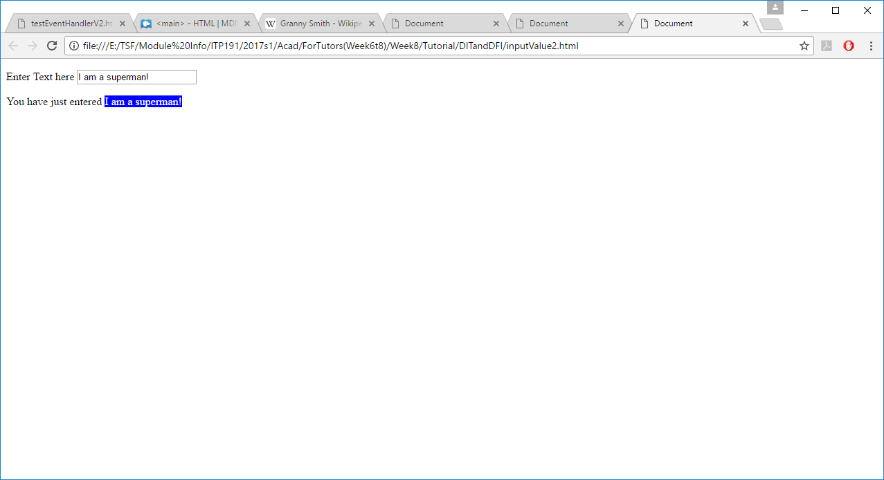

<!DOCTYPE html>

<html lang="en">

<head>

<meta charset="UTF-8">

<title>Document</title>

<style>

span#echoText{ background-color:blue; color:white}

</style>

<script>

//function to be called when keyup

function updateChanges(){

}

</script>

</head>

<body>

<p>Enter Text here <input type="text" id="userInput" onkeyup=" "/></p>

<p> You have just entered <span id="echoText"></span></p>

</body>

</html>

(b) Inline handler is used in (a). Modify the code above to use addEventListener to register the handler for the userInput.

1. (a) What is the root element of a HTML DOM (Document Object Model) tree?

(b) What is the root element of a BOM (Browser Object Model) tree?

(c) The ___________ lets JavaScript communicate with and change a web page.

(d) The ____________ allow JavaScript to interface and interact with the browser itself